МИНИСТЕРСТВО НАУКИ И ВЫСШЕГО ОБРАЗОВАНИЯ  
РОССИЙСКОЙ ФЕДЕРАЦИИ

федеральное государственное автономное   
образовательное учреждение высшего образования  
«Самарский национальный исследовательский университет   
имени академика С.П. Королева»

(Самарский университет)

Институт информатики и кибернетики

Кафедра геоинформатики и информационной безопасности

**Отчет по лабораторной работе №2**

Дисциплина: «Развертывание и жизненный цикл программного обеспечения»

Тема: **«Git and CI»**

Выполнил: Моисеев И.А..

Группа: 6412-100503D

Самара 2023

**TASK**

Steps

1. Download Gitlab-Bitnami vm image from https://bitnami.com/stack/gitlab/virtual-machine
2. Create repo in gitlab with sources of your app Upload <https://github.com/olindata/sample-gitlabci-cpp-project> to your Gitlab server.
3. To unblock SSH https://docs.bitnami.com/virtual-machine/faq/get-started/enable-ssh/
4. https://askubuntu.com/questions/204400/ssh-public-key-no-supported-authentication-methods-available-server-sent-publ
5. Install GitLab Runner using the official GitLab repositories https://docs.gitlab.com/runner/install/linux-repository.html
6. Update /etc/gitlab/gitlab.rb to disable https on gitlab (yes, it is not for production)

# use here your IP, but is must be HTTP

external_url 'http://192.168.88.228'

nginx['redirect_http_to_https'] = false

nginx['ssl_verify_client'] = "off"

1. Reconfigure GitLab for the changes to take effect:

$ sudo gitlab-ctl reconfigure

1. Register runner. Choose shell executor type. Use your ip and registration-token for command below:

$ sudo gitlab-runner register --url http://192.168.88.228/ --registration-token yqjsLYNFrbjaC-QhmycE

1. Edit .gitlab-ci.yml to run runner in shell mode (without Docker)

job:

script:

g++ helloworld.cpp -o helloworld

1. Run Pipeline: CI/CD > Pipelines > Run pipeline

**PROCEDURE**

Download and open the Gitlab-Bitnami VM:

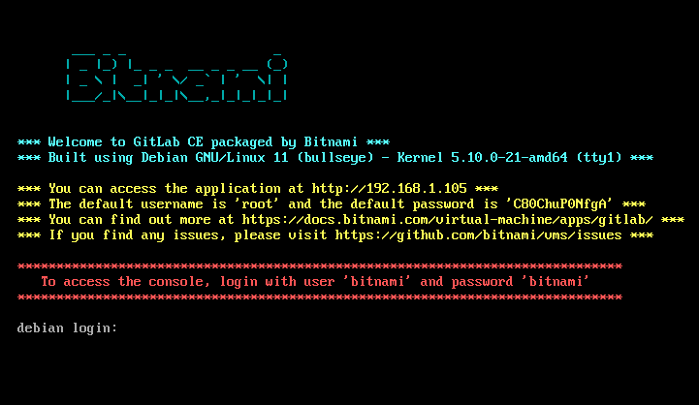

Get normal password

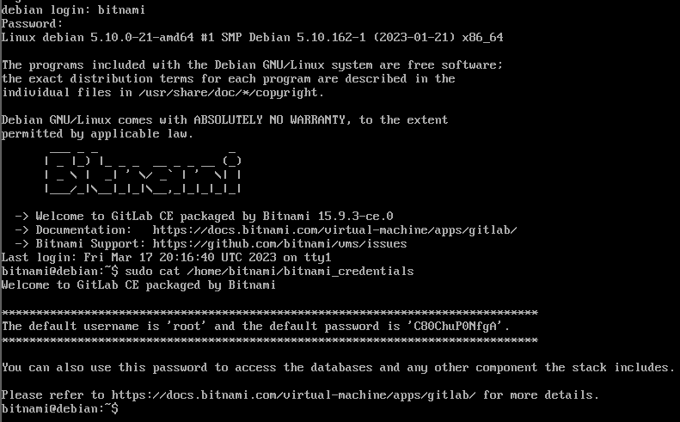

Login into GitLab on host machine on <https://192.168.1.105/>

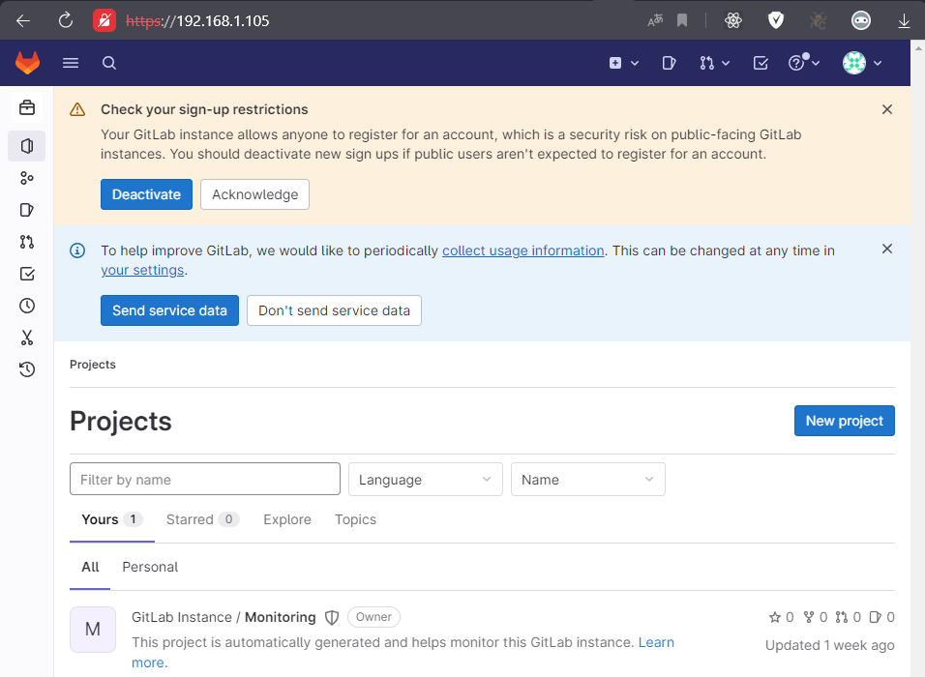

Cloning repository to VM

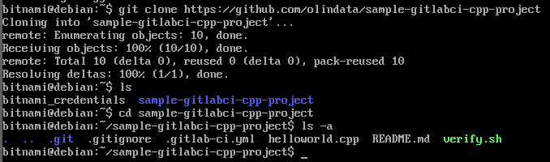

Create empty project

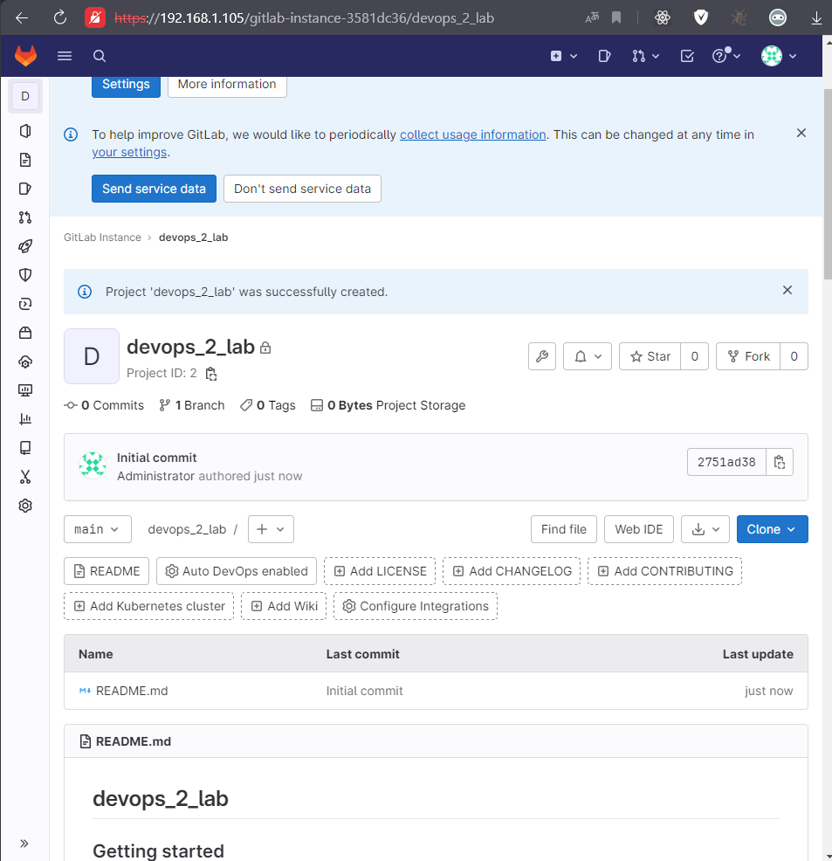

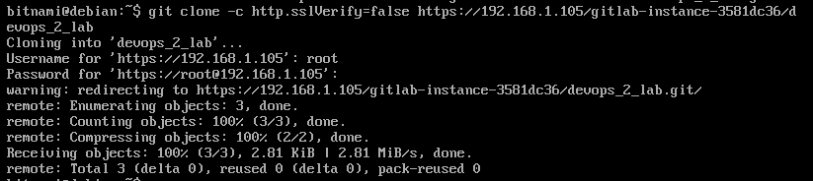

Enable SSH on that VM:

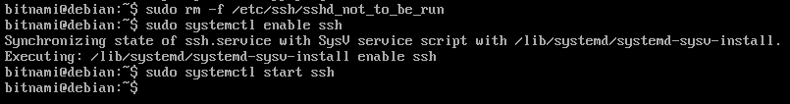

Edit the SSH configuration file to support password authentication:

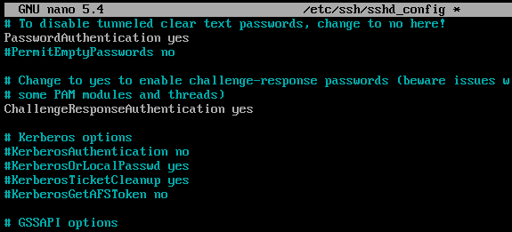



Set Email and UserName



Git add, commit and push

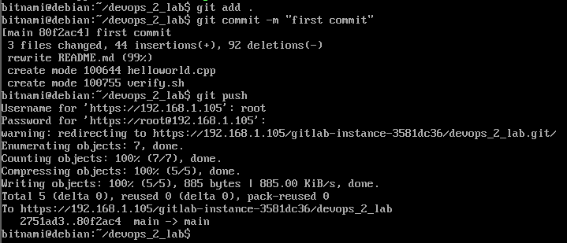

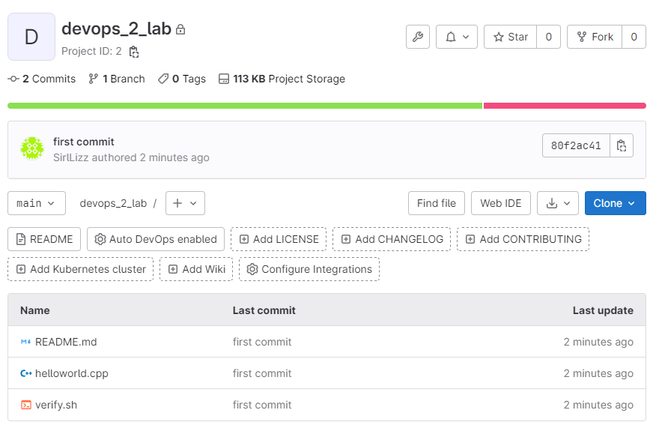

Install GitLab Runner:

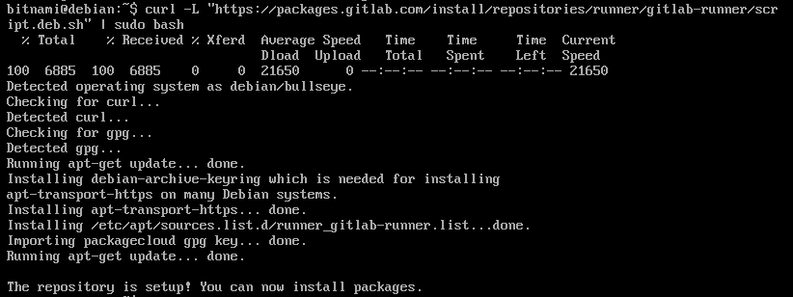

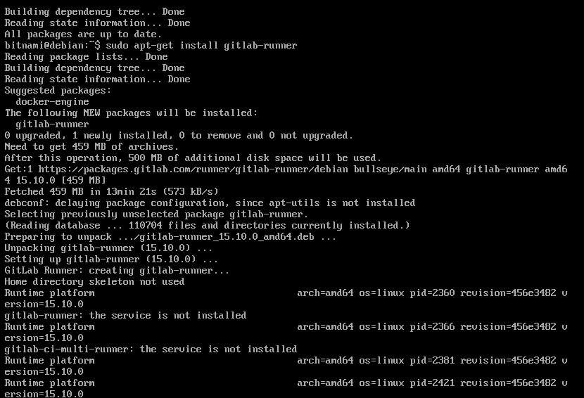

Update the /etc/gitlab/gitlab.rb file to disable HTTPS on GitLab:

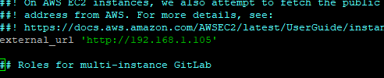

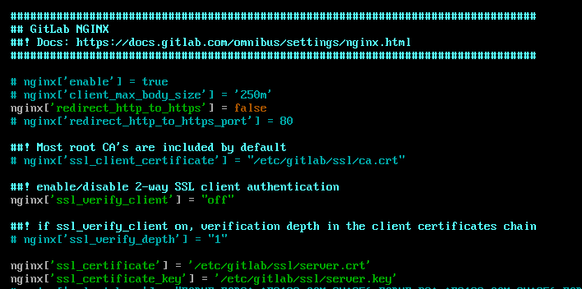

Reconfigure GitLab for the changes to take effect

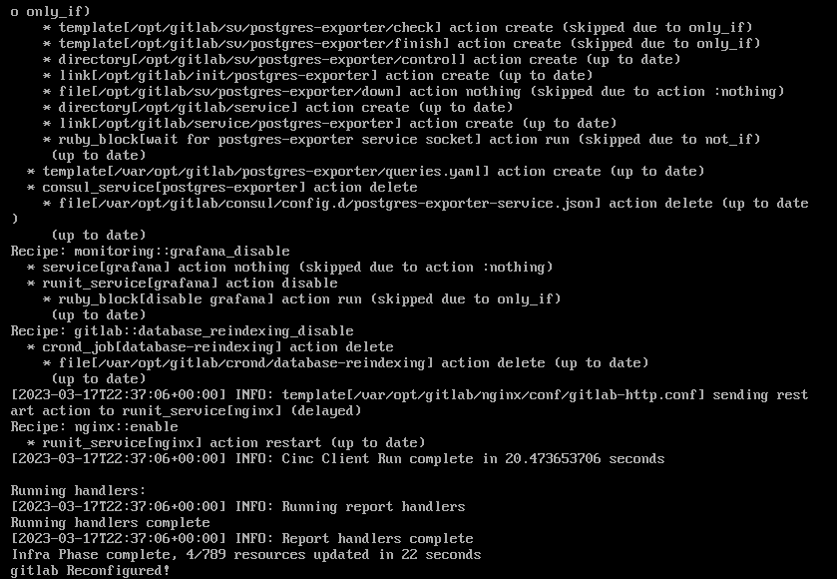

Open the GitLab server to get the runner registration token:

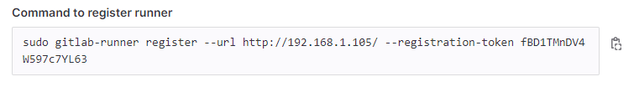

Register a runner:

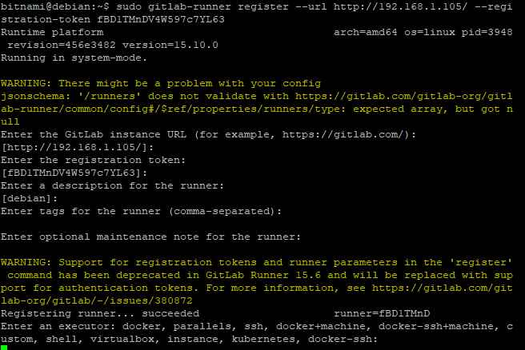

In the project directory, edit .gitlab-ci.yml to run runner in shell mode:

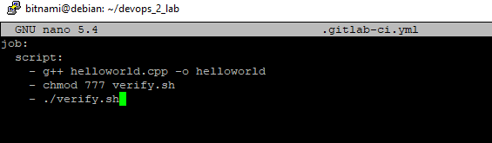

Commit and push the changes to the server:

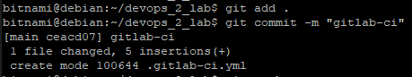

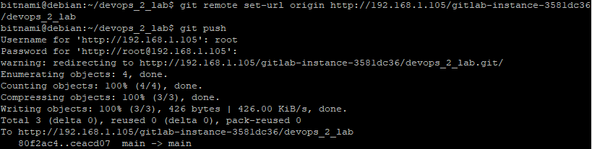

Check if the pipeline runs successfully

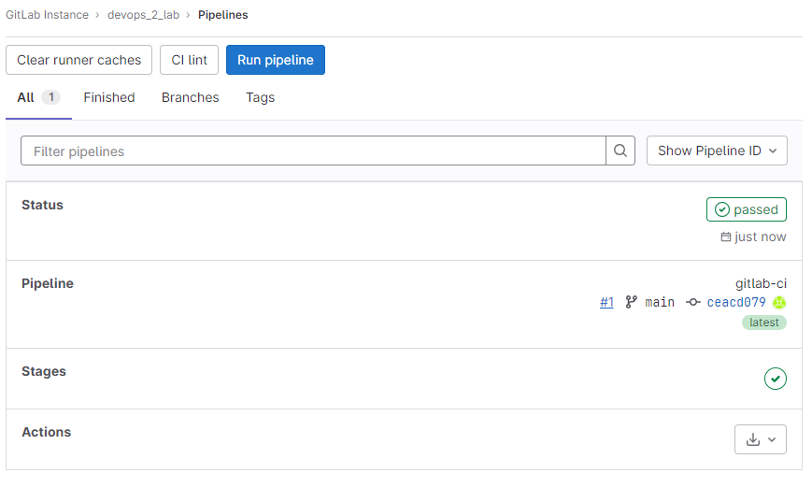

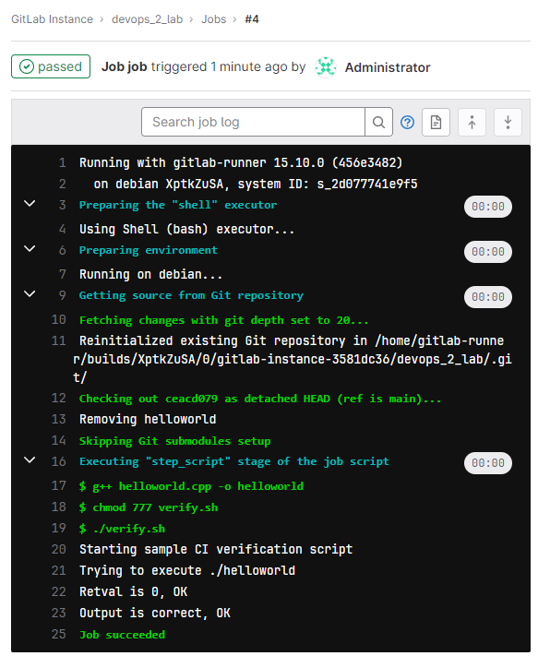

The pipeline runs successfully.